April 12, 2021

Dr. Jenahvive Morgan

College of Engineering

Michigan State University

219 Wilson Road

East Lansing, MI 48823

Dear Dr. Morgan,

Attached is a copy of Section 23, Team 5’s Project #2 Final Report for EGR 100, Spring 2021.

This report describes what was needed to construct a new HFC for a class 8 vehicle as well as the modifications and other designs used for interpreting what would be needed in the final design. There were 4 different calculations used for creating the design which our group decided were the most important for inventing the engine. A HFC is becoming increasingly more in demand for companies as electric cars become more popular and useful. The biggest problem dealing with electric vehicles is trying to find an efficient and cost-effective replacement for the fossil fuel powered engine. As technology begins to come further it is much more possible to design a good electric powered engine with a HFC and that is what this project talks about.

If any questions are needed for this project, please email anyone in our group. I hope this project meets all the requirements.

Sincerely,

Trinity Johnson, Elzie Honicutt, and Jimmy Kulas

**Introduction**

In this report the most efficient way to build a hydrogen fuel cell was used to help find new and innovative way for a class 8 vehicle to function with an electric motor. The class 8 vehicle consisted of semi-trucks and buses which need more power than a normal car that does not need as hefty of an engine. Hydrogen Fuel Cell (HFC) is an alternative method to provide electric power for vehicle propulsion. Hydrogen Fuel Cells operate by converting hydrogen stored in tanks and oxygen from the atmosphere into power in the fuel cell stack. The reason for the need of this version of power for vehicles, especially large ones such as semi-trucks, is because the elimination of fossil fuels helps the environment decrease carbon emissions.

During this project for developing a new hydrogen fuel cell, the report focused on the Hyundai Nexo, Honda Clarity, and the Toyota Mirai as an example car for using a HFC [3]. The model expressed most within the report was the Toyota Mirai. This model of the Toyota was not a class 8 vehicle so modifications with size, power, and materials needed to be made to compensate for the size of larger vehicles. With HFC’s being in an increasing market for a useful propulsion system in smaller vehicles, like the Toyota Mirai, there needed to be a newly constructed model for a more powerful vehicle. This report focused on the building of a new fuel cell for class 8 vehicles.

The methodology used other resources on hydrogen fuel cells to determine the most cost effect and efficient way of for building a big enough HFC for a large-scale engine in big vehicles. The results for the report established graphs and showed which methods worked for the development of the HFC.

The results and conclusion of this paper describe the different variations of the project and the calculations needed to build the HFC. These sections list off different ways to build the HFC, the errors in calculations, and the wrap up of the report.

Overall the goal of the report was to find the best way to build a HFC for class 8 vehicles by using other cars as a different reference point since a lot of the parts are not up to scale for class 8 vehicles.

**Methods**

The first part of the project was to make a schedule for the design to be completed. After the schedule was made, research needed to be done for finding out the ideal model of the HFC. The data was collected from google scholar and then calculations needed to be made.

To test for the new HFC, 4 different calculations, calculating the size of the fuel cells, getting the bill of materials, required flow rate, and finding the optimum pressure of the vehicle [2]. needed to be made for the product of the hydrogen fuel cell. The first step was to find the materials that were needed to build the HFC. An outline of the Toyota Mirai was used to find the different parts for the final design of the HFC. The second step made calculations for the fuel cell stack. Each fuel cell on the Toyota Mirai is 1.34 mm and the entire fuel cell stack is comprised of 370 cells [1]. However, in a class 8 vehicle, there needed to be double the amount of fuel cells to compensate for the power of the vehicle so 740 were used for design of the fuel cell stack. To get the final size of the fuel cell stack 1.34 mm needed to be multiplied by 740 cells which resulted in the size of the fuel cell stack [4]. The third method was to find the required flow rate of the HFC. This step involved was to look at the amount of power needed for a class 8 vehicle. The final step of organizing the HFC design was to find the cost of the materials. The cost involved gathering the bill of the materials, shown in the second step, and calculating the cost based on size of each material and the weight. After the cost was calculated, the initial design was completed for the model of the HFC inside a class 8 vehicle [5].

The bill of materials was determined by researching other vehicles to reference as a class 8 vehicle needed to be built from these materials and then scaling up the sizes in smaller cars such as the Toyota Mirai to find the size of the fuel cell stack. The fuel cell needs to run between a minimum rate for a reaction to happen and has a maximum rate determined by a multitude of things from pressure, volume, moles of gas, the gas constant R and temperature. These are all related to each other using the ideal gas law so if needed the hypotheses can be tested by seeing how a given element will change at given conditions. Finally, there were 2 strategies used called cluster and regional strategy to determine the optimum pressure for the HFC. The cluster strategy used stations that were close together, such as in big cities, to refuel quickly with less pressure. This strategy applies to smaller cars and uses 350-500 bars of pressure. The regional strategy, stations spread across a great distance, would more likely be used for large class 8 vehicles. This has an optimum pressure of 700 bars because of the cost between stations.

All these methods of developing a new HFC for a class 8 vehicle showed results which helped for the initial design.

**Results**

The data used to formulate a mockup of a fuel cell fit for a class 8 vehicle was based on the three most popular fuel cell powered vehicles on the market including the: Hyundai Nexo, Honda Clarity, and the Toyota Miria. When completing the bill of materials for the class 8 vehicle fuel stack, the Toyota Mirai was used for reference due to the availability of data on their fuel cell design. The average gasoline powered car needs roughly 12.6V to power the battery while the average class 8 vehicle needs 24V; thus, it was assumed that the fuel cell stack would be roughly double the size of the fuel cell stack in the Mirai. The Mirai has 370 cells in its stack, and with the average fuel cell creating .7V, the stack is producing 259V to power the car. One top of this they also use a fuel cell boost converter that has a maximum output of 650V. Meaning that the stack for the class 8 model needed to be 740 cells to produce 518V to power the vehicle, and a boost converter would need to generate 1300V. Around each cell a set of seals and bipolar plates are needed where one of each set goes on each side of the fuel cell. Normally there are cooling plates included in these sets, but an alternative cooling method was chosen to cool down the cell stack. Instead, an extra set of holes will be drilled into the bipolar plates to allow cooling tubes to pass through where a coolant can flow through to cool down the stack.

For the battery, it would need to be able to handle 518V of electricity, which is why the Borg Warner V4 3P Solution battery pack was chosen. To account for the boost converter the Borg Warner eTurbocompound has promise, but the company would need to scale up the number of volts of electrical energy it can produce to match the voltage needed for a larger electric type of vehicle. This is indicated in the bill of materials with an asterisk. For the fuel tanks, the vehicle needs to hold the equivalent of 300 gallons of fuel which the tanks equate to such. It should be noted that this setup is quite expensive, but the most expensive item in the BOM has the opportunity for bulk order as indicated with a dollar symbol.

Table 1: Bill of materials for the HFC including part number, needed quantity, weight, and total cost



This design, once again, was cultivated around the Toyota Mirai and it was due to the ability to gather data on the fuel cell design, power obtained compared to other fuel cell vehicles, and the cost of the parts that make up the fuel cell. The power output of the Mirai totals to a maximum 114kW, thus exceeding its counterparts which can be seen in in Table 2 and Figure 1.

Table 2: The 3 Most popular HFC model cars and their power in kW



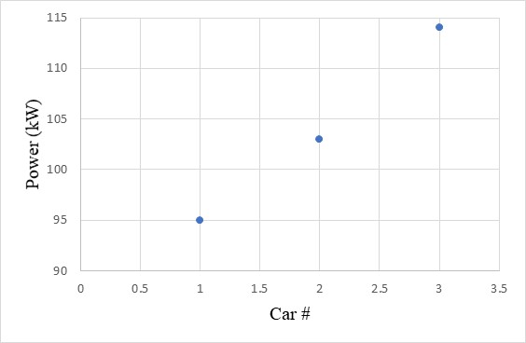

Figure 1: Maximum Power Output of Each HFC Vehicle

Then when taking the most expensive parts of the fuel cell, namely the MEA and the Bipolar Plates, into consideration the Mirai comes out on top with the most expensive design. That is based on the materials that were chosen in the bill of materials. But due to the output of power and available information, it was the best car to reference for efficiency for the class 8 vehicle.

Table 3: Different HFC systems for each vehicle and prices of most expensive components



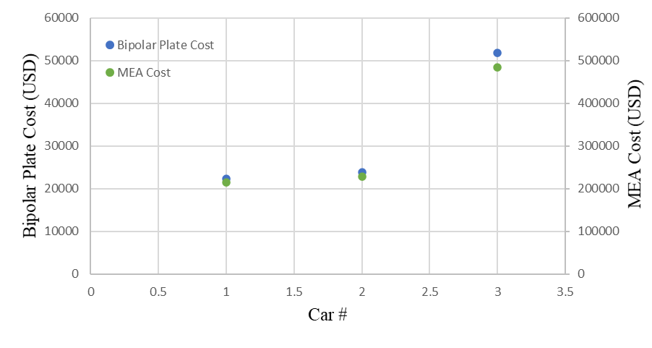

Figure 2: Cost Comparison of Bipolar Plates and MEA

Up to this point, a fuel cell-based class 8 vehicle has been determined to be highly expensive, but it proves to cost much more when looking at the amount of money to fuel this vehicle per year compared to the average diesel fueled vehicle. For this analysis it was decided to compare the price of the average semi-truck to a fuel cell/electric based semi-truck. First and foremost, it should be noted that the average semi is fueled using diesel fuel while a fuel cell-based semi would be powered using hydrogen. The average cost of diesel fuel is $3.08 while hydrogen costs $10/kg of hydrogen. The average amount of miles driven by a semi is 45000mi per year, and of that 1 gallon of fuel covers 6.5 miles. Therefore, after some computation totals to $21,323.07 to fuel a diesel-powered semi per year as seen in table 4.

Table 4: Diesel Fuel Powered Semi Yearly Cost Analysis



To compute the yearly cost of fuel for a fuel cell semi, was not as simple as there are not many references to collect data from. First the fact that the average fuel cell-based car can travel twice the distance of its gasoline powered counterpart and it was assumed that this would roughly hold true for the class 8 vehicle. Therefore, the typical fuel cell semi would run 4200mi on one tank of fuel. Secondly, the fact that 4kg of hydrogen, which is roughly 8.8 pounds, equated to 4 gallons of gas was considered. It was paired with the knowledge that the minimal fuel tank of a semi is 849 pounds, meaning that the fuel tank for the fuel cell powered semi would need to be around 96kg. Downside being that that means the truck would have to be refilled roughly 3x as often to meet the 300-gasoline average of a diesel semi. Thus, with some minor calculations, it was calculated that the fuel cell semi would need to be refilled 32 times a year. Taking those calculations, a step further, it was calculated that it would cost $30,535.71 to power the fuel cell powered class semi-truck, which is a $9,212.63 dollar difference per year. For a 10-year timespan, which is the average lifespan of a semi-truck, that is $92,126.3 difference. The optimum pressure of the vehicle was calculated to be 700 bars for a regional standard rather than a cluster because a class 8 vehicle tends to travel a farther distance.

Table 5: HFC Powered Semi Yearly Cost Analysis



Overall, when looking into the amount of money it would take to build the fuel cell and then the fuel to power such a vehicle is astronomically high compared to the standard diesel-powered class 8 vehicle. In the long run, though this vehicle would be much kinder on the Earth, economically this is not efficient.

Table 6: Overview of the yearly fuel cost analysis for diesel and HFC powered semi



**Conclusion**

At the end of the project all the calculations were acquired to build a HFC with 4 different calculations of the bill of materials, size of the fuel cell stack, flow rate, and the optimum pressure. These calculations all contributed to a fuel cell that was pricy but the most efficient engine possible for electric powered cars. The bill of materials and size of the fuel cell stack work together because to find the size there needed to be a list of the materials. The list of the materials made it possible for the size of the fuel stack to be made for the HFC.

During the design phase of the HFC there were different iterations to end up at the final design of the projects HFC. The biggest problems occurred in the beginning when trying to find the bill of materials and the size of the fuel cell stack because there is no specific class 8 vehicle setup for a HFC, and the materials needed to be improvised. After finding these the optimum pressure and flow rate came easier than the first steps because all the information was gathered. The cost was another hard calculation due to their being little information and the information that was given made the fuel cell seem still a bit pricy.

In the end, the project was completed for finding the best HFC that could be made for an electric vehicle. Even though Electric vehicles are still not the best cars in the market for power, the cars are becoming more and more efficient as well as cost effective every day.

**References**

[1]   US Department of Energy, “Parts of a Fuel Cell,” *Energy.gov*. [Online]. Available: https://www.energy.gov/eere/fuelcells/parts-fuel-cell. [Accessed: 30-Mar-2021].

[2]   *Hydrogen & Fuel Cells: Science Behind Fuel Cells*, 17-Nov-2020. [Online]. Available: https://sepuplhs.org/high/hydrogen/hydrogen.html#:~:text=A%20typical%20hydrogen%20fuel%20cell,can%20be%20connected%20in%20series. [Accessed: 30-Mar-2021].

[3]   D. Dorian, “2021 Hyundai Nexo Review, Pricing, and Specs,” *Car and Driver*, 23-Mar-2021. [Online]. Available: https://www.caranddriver.com/hyundai/nexo. [Accessed: 30-Mar-2021].

[4]   B. Halvorson, “2017 Honda Clarity Fuel Cell,” *Car and Driver*, 14-Nov-2020. [Online]. Available: https://www.caranddriver.com/reviews/a15096419/2017-honda-clarity-fuel-cell-first-drive-review/[Accessed: 30-Mar-2021].

[5]   M. Maddireddy, “2021 Toyota Mirai Review, Pricing, and Specs,” *Car and Driver*, 23-Mar-2021. [Online]. Available: https://www.caranddriver.com/toyota/mirai. [Accessed: 30-Mar-2021].